**SPECIAL ENGINEER (Forwarded for scrutiny to Office Section)**

**STEP -1:**

At first login to Service plus web portal**: (**<https://tathyasathi.bangla.gov.in/>).

Login as “**Special Engineer**” in Service plus web portal.

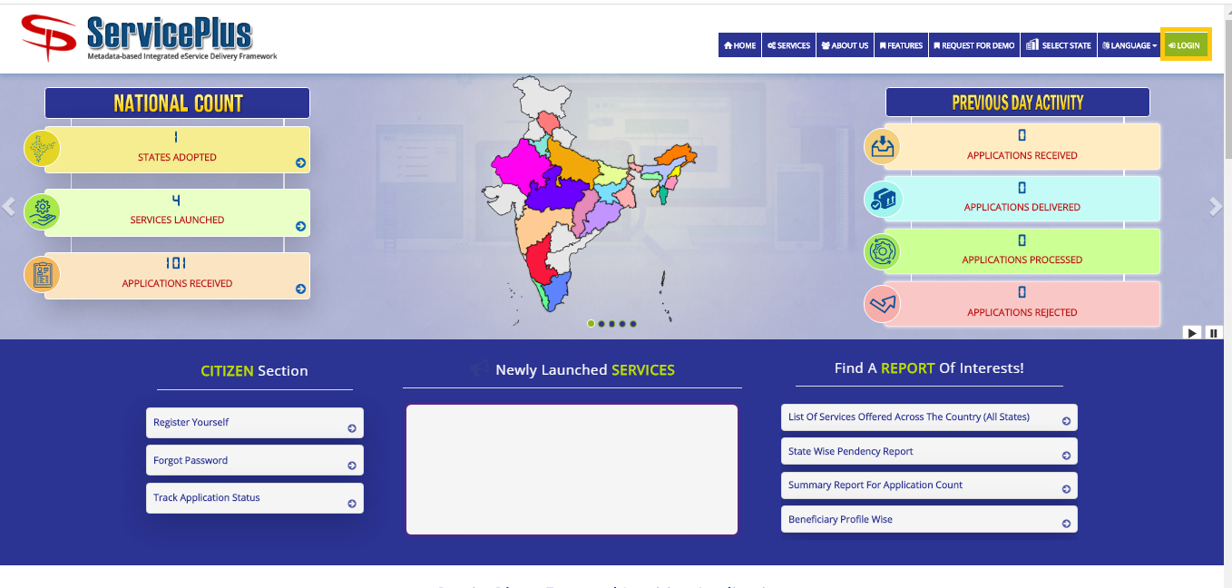

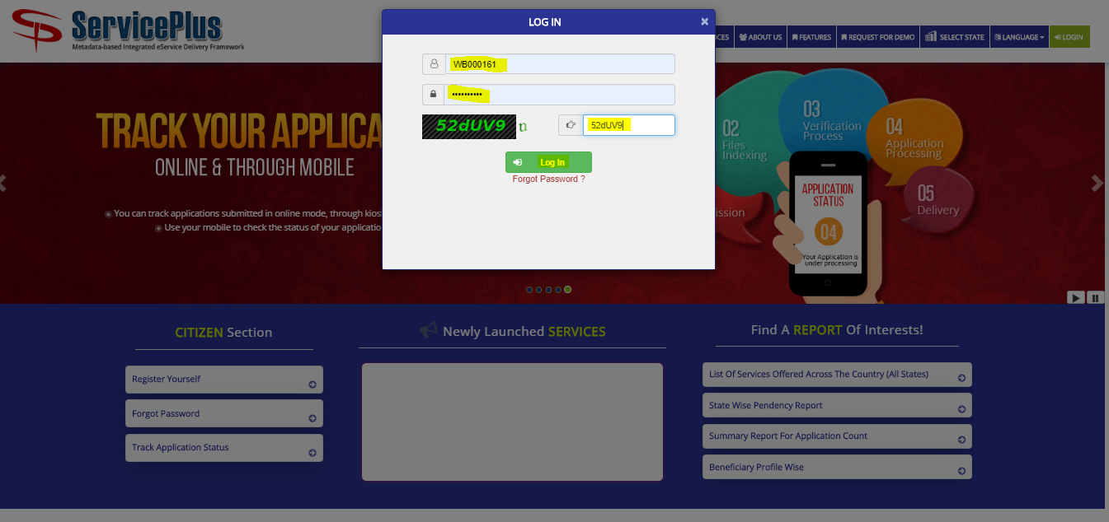

**Step 2:**

Now Go to **“Message Box”** and select **“Inbox”**.

In Inbox select the service **“Application for Maintenance of Flats in Bidhannagar Municipal Corporation Area”** and select the task **“Application Receipt by Special Officer”** and select **“Get Data”.**

Select **“Pull”/ “Take Action”** to take action.

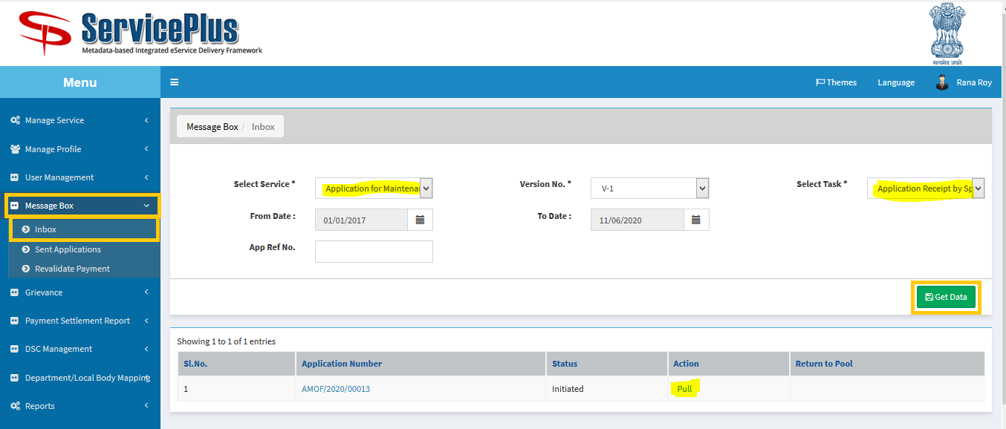

**Step 3:**

Select **“View Processing History”** to see the history of the application.

Action of the form can be taken by **Special Officer** by taking action in two steps to **forward** and **Forward To-Supervisory Head Clerk** for Verification to “**Head Clerk”** and Give remarks and **submit**.

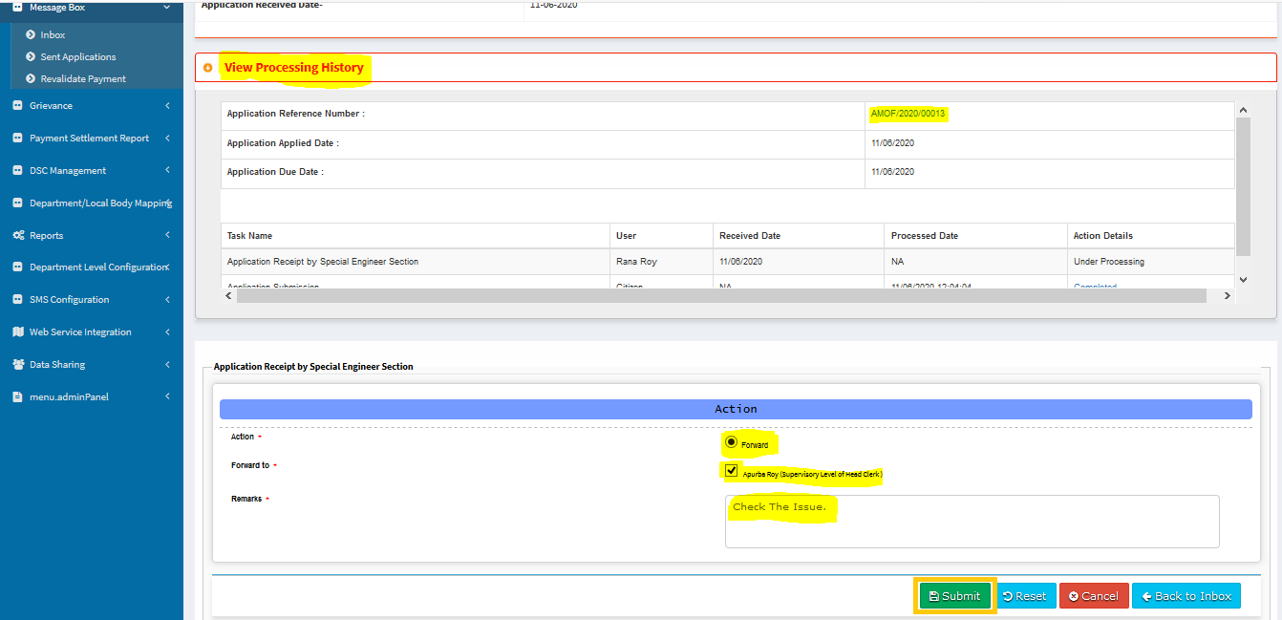

Now the application sent to head clerk successfully.

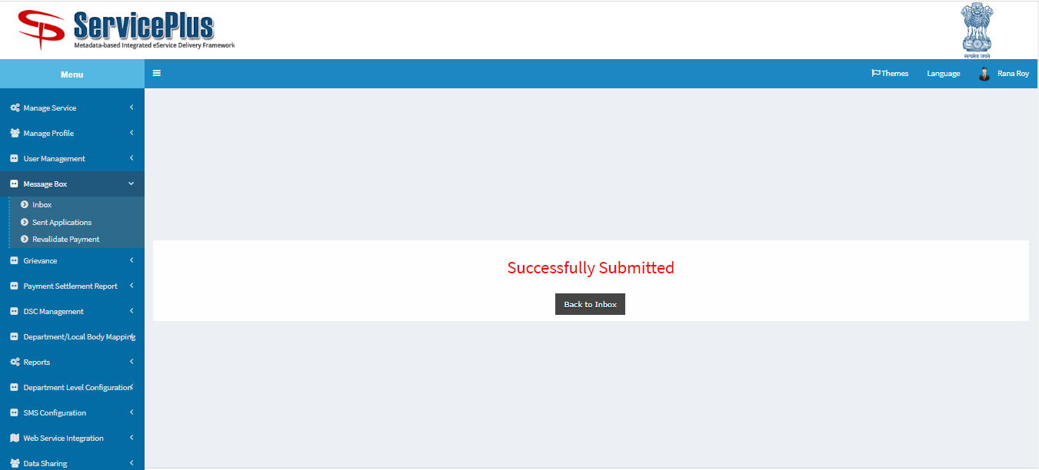

**OFFICE SECTION (Scrutiny and Forwarded to Special engineer)**

**Step 4:**

At first login to Service plus web portal**: (**<https://tathyasathi.bangla.gov.in/>).

Login as “**Head Clerk**” in Service plus web portal.

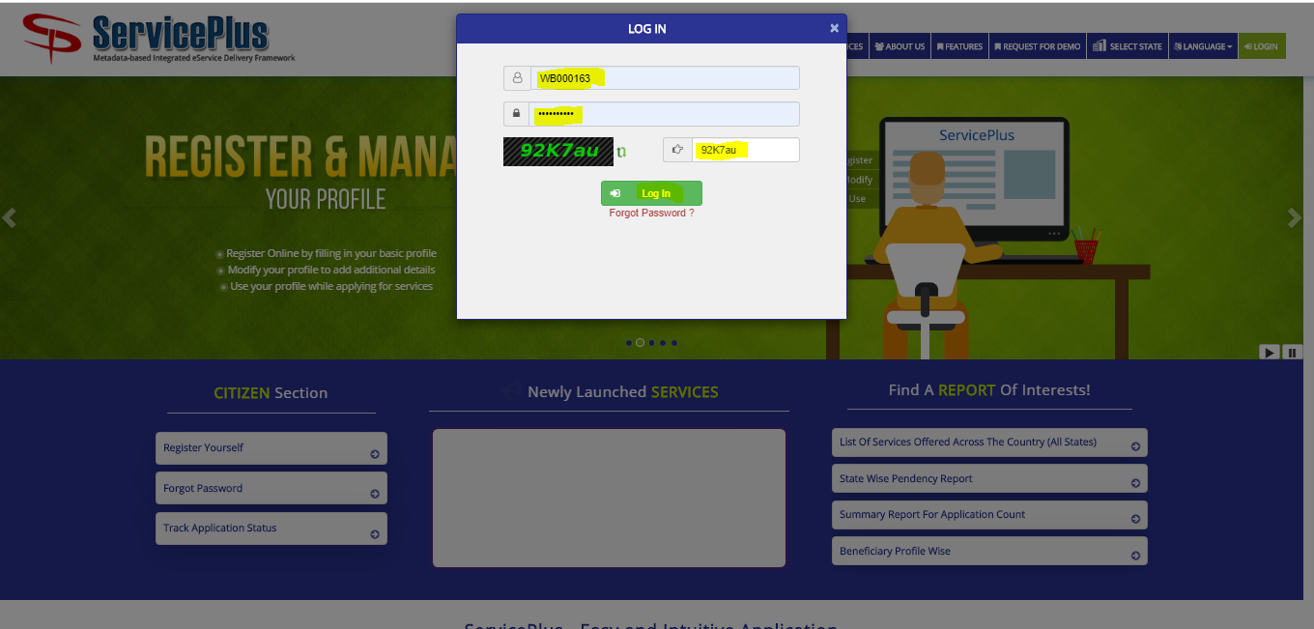

**Step 5:**

Now Go to **“Message Box”** and select **“Inbox”**.

In Inbox select the service **“Application for Maintenance of Flats in Bidhannagar Municipal Corporation Area”** and select the task **“Verify and Prepare Report by Engineer”** and select **“Get Data”.**

Select **“Pull”/ “Take Action”** to take action.

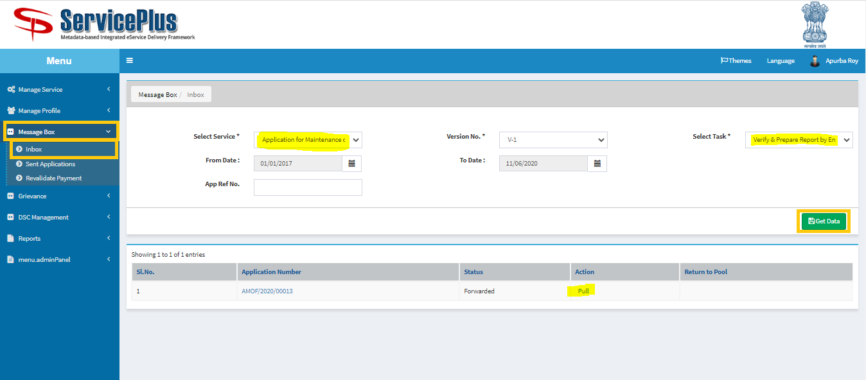

**Step 6:**

Select **“View Processing History”** to see the history of the application.

Now **Head Clerk** can process the application by forwarding to –

**Application Submission** **Short fall**

**Issuance of date for Maintenance by Special Engineer**

Click on **Forward** then **Issuance of date for Maintenance by Special Engineer** and **submit.**

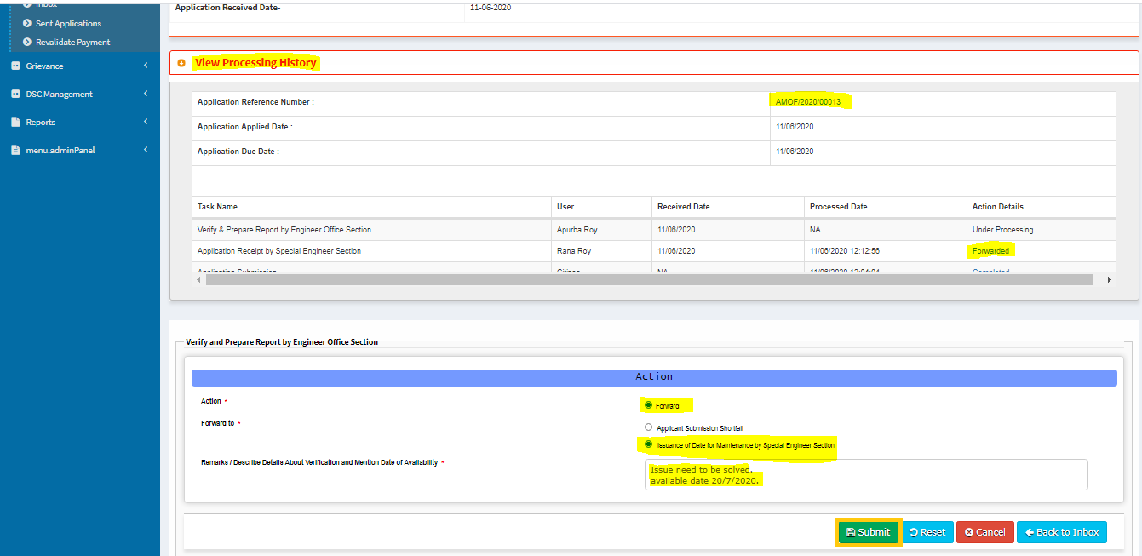

Now the application sent to **Special Engineer** successfully.

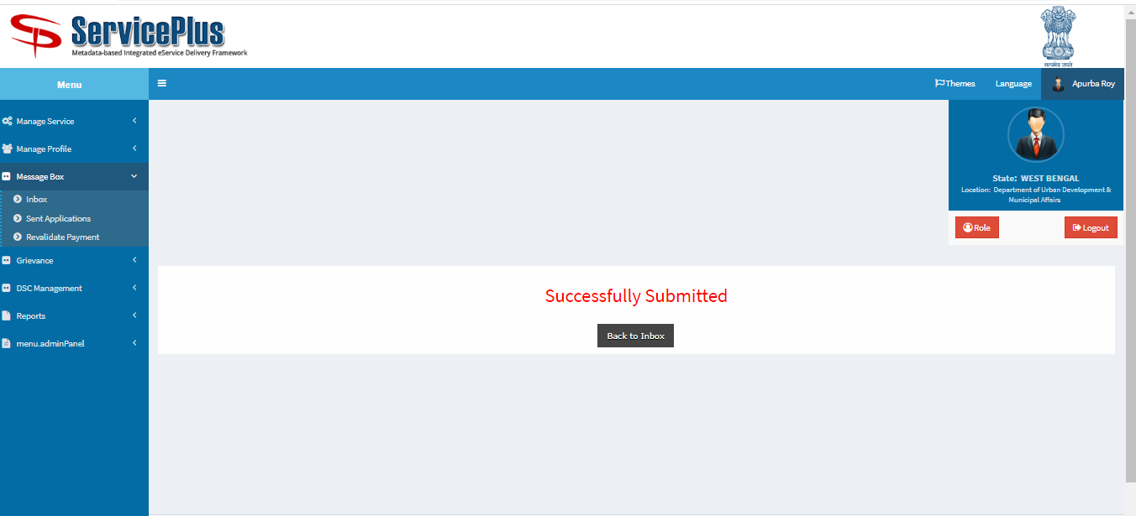

**SPECIAL ENGINEER (Maintenance Date to fixup the issue)**

**Step 1:**

Again Login as **“Special Engineer**” in Service plus web portal.



**Step 2:**

Select the service **“Application for Maintenance of Flats in Bidhannagar Municipal Corporation Area”** and select the task **“Issuance of Date for Maintenance by Special Engineer”** and select **“Get Data”.**

Select **“Pull” / “Take Action”**.

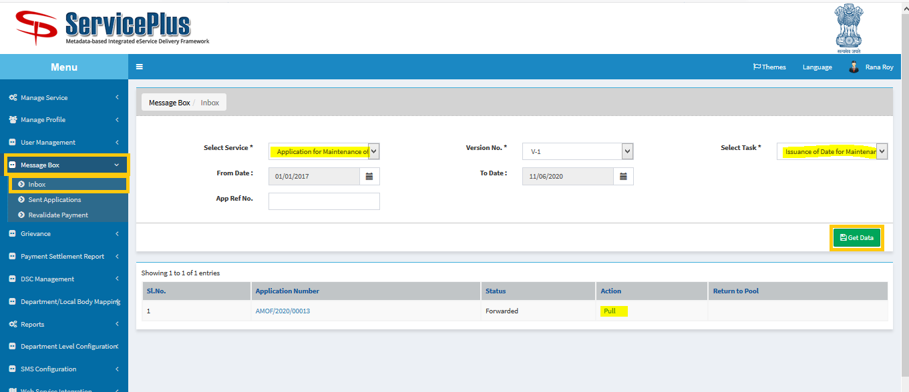

**Step 3:**

Select **“View Processing History”** to see the history of the application.

Action of the form can be taken by **Special Engineer** by taking action to **forward** or **reject.**

Now select **forward** then **Applicant Confirmation** andgive **maintenance date** and **submit.**

Or reject the application by selecting **Reject** and **submit**.

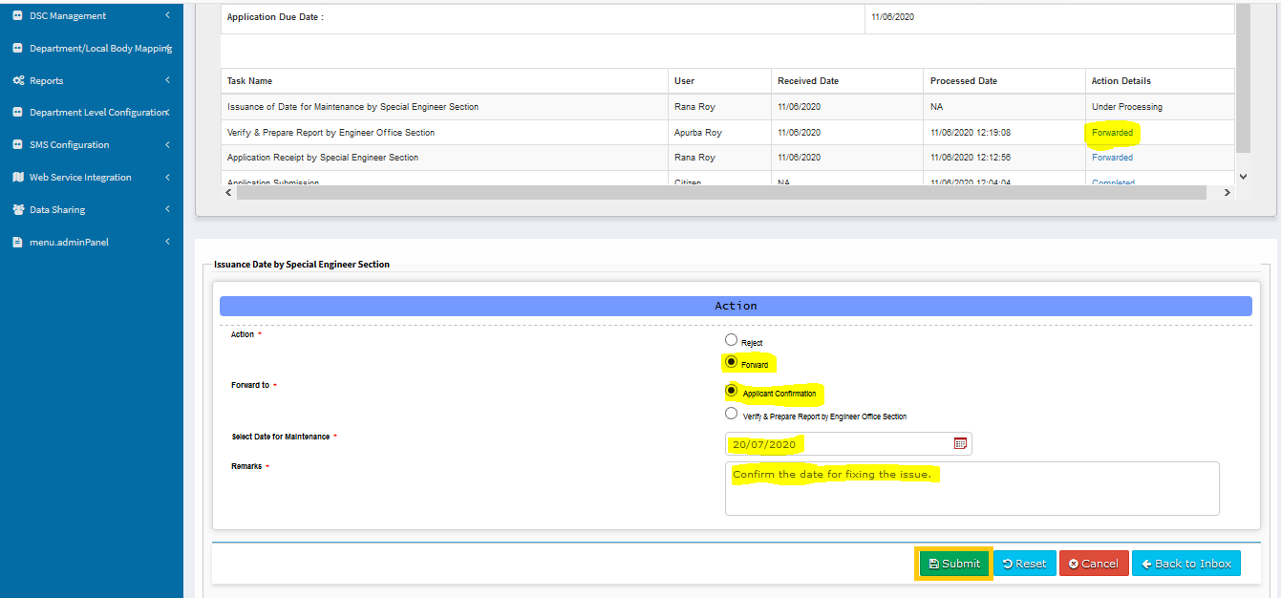

After successful submission this message will be shown.



**OFFICE SECTION (Deliver The Application)**

**Step 1:**

Again Login as **“Head Clerk**” in Service plus web portal.



**Step 2:**

Select the service **“Application for Maintenance of Flats in Bidhannagar Municipal Corporation Area”** and select the task **“Confirmation by Engineer Officer Section”** and select **“Get Data”.**

Select **“Pull” / “Take Action”**.

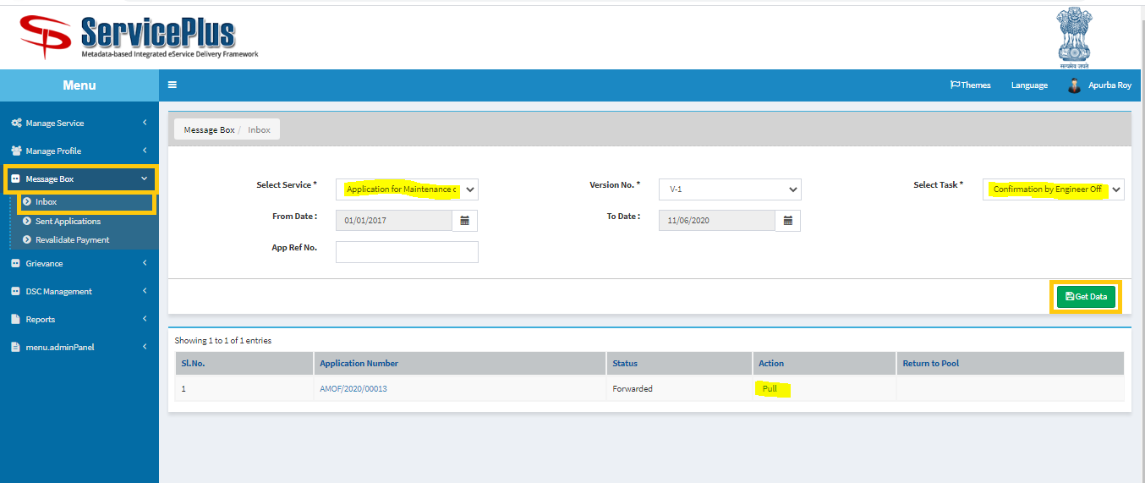

**Step 3:**

Select **“View Processing History”** to see the history of the application.

Action of the form can be taken by **Head Clerk** by taking action to **deliver.**

And **submit** by giving **remarks.**

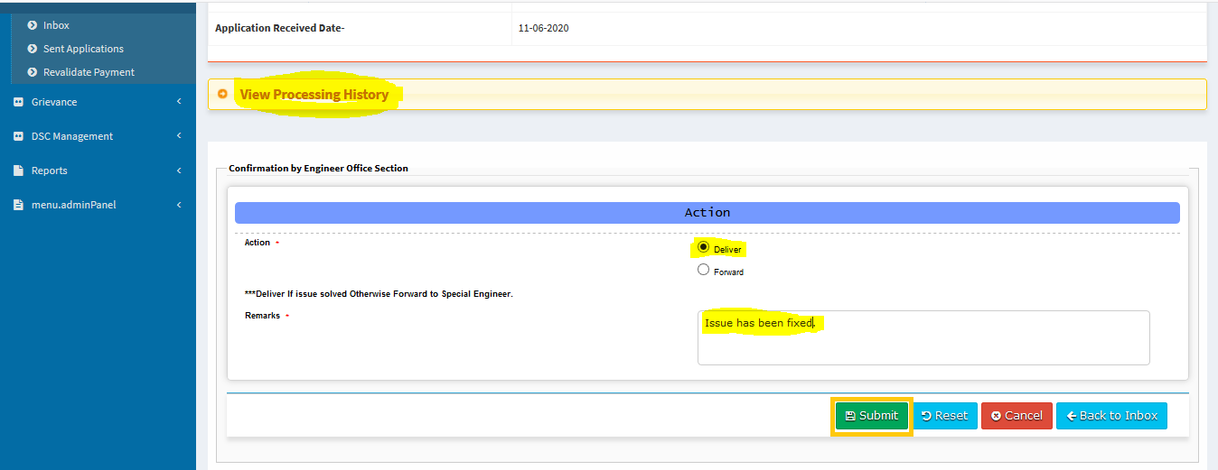

If issue not solved then the application forward to Special engineer again.

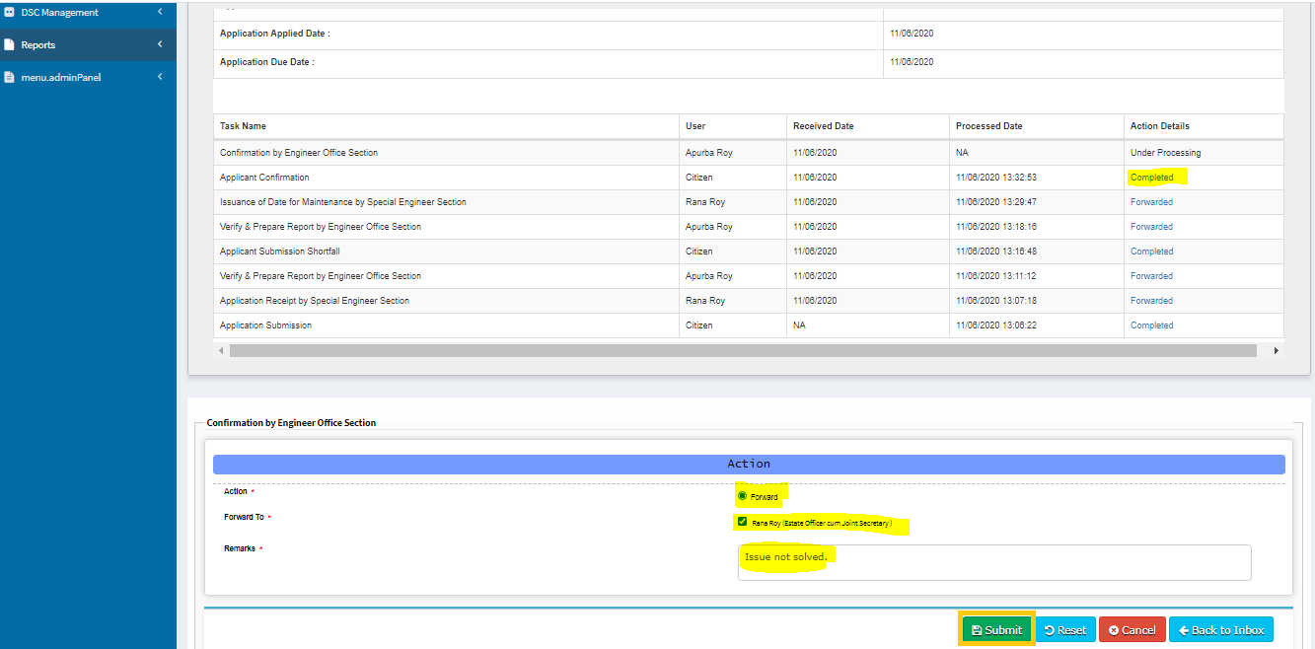

After successful submission this message will be shown.



**SHORTFALL CASE**

**OFFICE SECTION (Shortfall)**

**Step 1:**

Again Login as **“Head Clerk**” in Service plus web portal.



**Step 2:**

Select the service **“Application for Maintenance of Flats in Bidhannagar Municipal Corporation Area”** and select the task **“Verify and Prepare Report by Engineer Section”** and select **“Get Data”.**

Select **“Pull” / “Take Action”**.



**Step 2:**

Select **“View Processing History”** to see the history of the application.

Action of the form can be taken by **Head Clerk** by taking action to **forward** and **Applicant Submission Shortfall.**

Mention the document(s) for Shortfall & put **remarks** then click on **submit**.

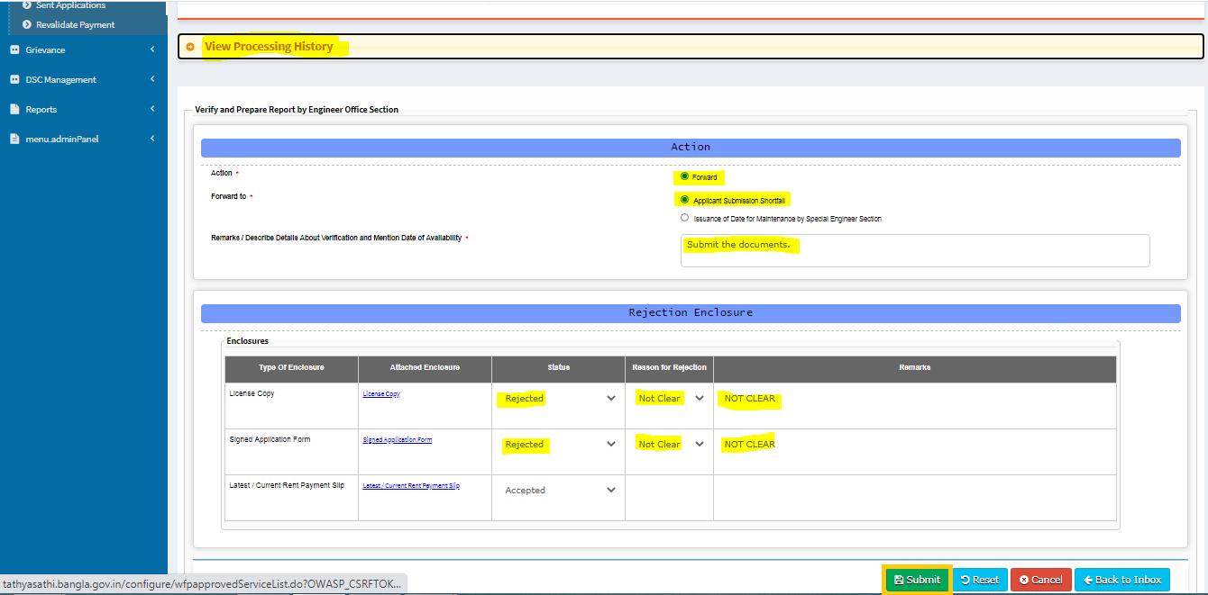

After successful submission this message will be shown.

